**MSc Physician Associate Studies 2019/20 & 2020/21**



**Programme Overview, Alumni Case Studies and the PA Student Society.** Here’s a [video](https://www.youtube.com/watch?v=KOWFtnqMPrw&) we’ve recently produced outlining the MSc PA Studies Programme. Also, our PA Society have some great examples of student activities, including an open day Q&A video and other stories on their [Instagram](https://www.instagram.com/uwepasoc/?hl=en) and [Twitter](https://twitter.com/UWEPASociety?ref_src=twsrc%5Egoogle%7Ctwcamp%5Eserp%7Ctwgr%5Eauthor) pages. Finally, please take the time to read through some of our alumni case studies below about their excellent work as graduate PAs in local GP surgeries.

**James Willis PA-R** (class of 2018)

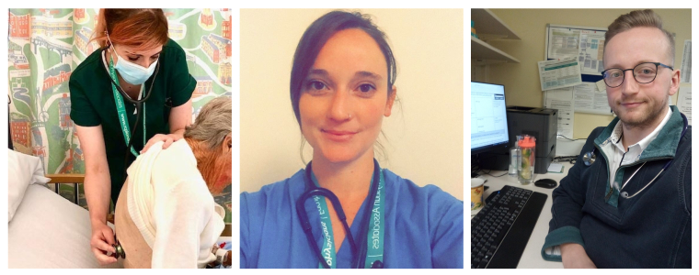Crest Family Practice, Bristol

“Day-to-day practice has changed considerably during the Covid-19 pandemic. At Crest Family Practice, we have moved to a total remote consultation model. This means that all consultations start as either a telephone triage call, or a videophone call. Typically I will do anywhere from 10-15 of these per day, depending on the workload coming through our booking lines in the morning.

“From these remote consultations I then decide whether the patient needs to be seen face-to-face. If I'm certain there is little-to-none Covid-19 risk to the patient and myself, I will invite the patient to the practice for a brief face-to-face consultation where I will revisit the pertinent positives and negatives in their clinical history, before conducting a focussed examination or procedure. If, on the other hand, I feel as though there is a risk of the patient presenting with Covid-19 then I will discuss the case with a senior GP and we will decide together the next steps.

“If we suspect a patient has Covid-19 then we invite the patient to the practice to run a 'car-park assessment'. This means that either myself or the GP will invite the patient (provided they are fit and well enough to do so) to drive to the practice car park, and remain in their car whilst we obtain a basic set of observations. We are especially interested in the patient's temperature, heart rate and oxygen saturations. If these are satisfactory we direct the patient to return home with self-isolation advice and safety-netting that if they deteriorate they can call us back in hours or speak to NHS 111 out of hours.

“However, if the patient is unwell and we have a high degree of suspicion of Covid-19 then we arrange for them to be admitted via the medical admissions unit. Thus far I have had to do this only for a couple of patients, but have gained invaluable experience from doing so.

“Away from clinical practice, I've also worked with the team here to do an audit on our patients who receive B12 intramuscular injections. This is a procedure which was recommended be suspended during the Covid-19 pandemic to mitigate risk to both patients and clinical staff. I worked on a project analysing which of our patients had critically low B12, and who had antibody positive pernicious anaemia. For these patients, we continued their B12 injections as there was a clear need to do so. For all other patients, we switched them to oral B12 supplementation. This has not just been good from reducing patient and staff risk during the pandemic, but has also helped the practice to offer more cost-effective treatment for patients.”

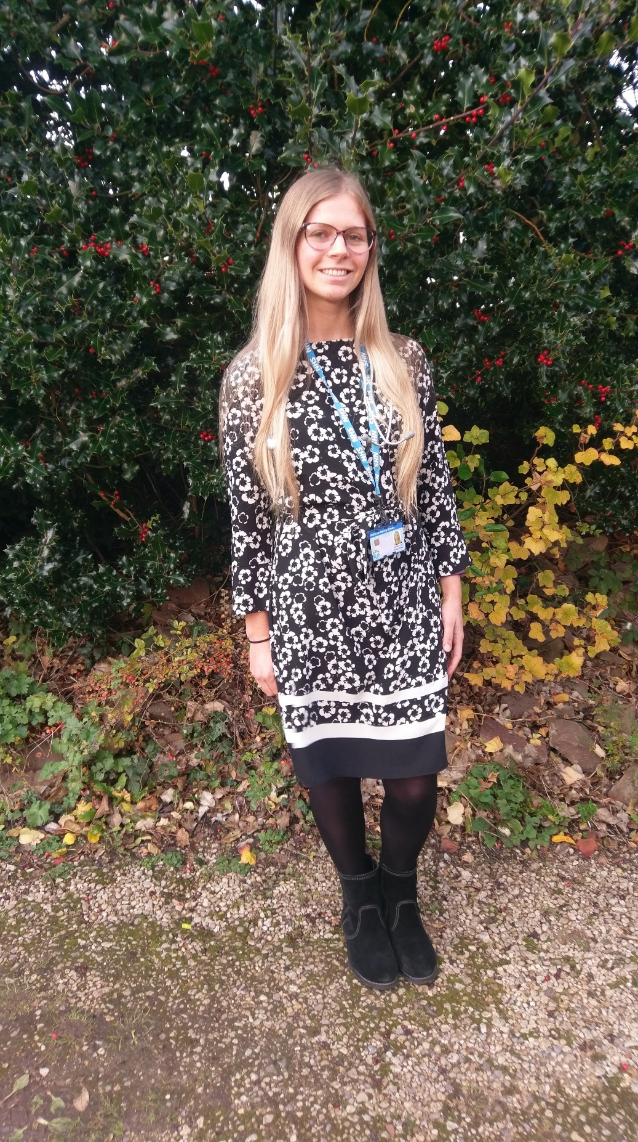**Sarah Bruce PA-R** (class of 2019)

Tinkers Lane Surgery, Wiltshire

“I started as a new Physician Associate (PA) in a GP practice in Wiltshire back in November 2019 so have been in my role just under 6 months. I am the first PA the practice has employed and they originally approached UWE and were interested in incorporating the role into their team. I work 5 days a week whereas all the doctors in the surgery work less than 3.5 days a week so I can provide good continuity of care and follow up patients in a timely manner. Working in General Practice is unique as a PA can mould to the specific workload gap that needs filling. My usual day consists of a combination of routine and emergency appointments with several long term condition reviews in the afternoon which involve reviewing blood test results and assessing patients for any signs/symptoms of their disease and managing risk factors such as hypertension, hypercholesterolaemia and lifestyle choices. I also cover shift gaps in the triage rota alongside two advanced nurse practitioners where we take all clinical calls into the practice and either manage on the phone or book into emergency slots for on the day review. As I’ve grown into the role I’ve started assisting the Diabetic Nurse with reviewing the diabetic cohort of patients, being trained up to perform annual Diabetic reviews and adjust medications to optimise their blood sugars. I have great supervision from the GPs in the practice and work within my scope of practice asking for advice when required. I really enjoy the variety of my job and feel very lucky to work for the NHS and in such a friendly practice. At my 3 month appraisal my GP mentor was delighted with my progress in gaining more competencies and commended my flexibility to adapt to the evolving role.”

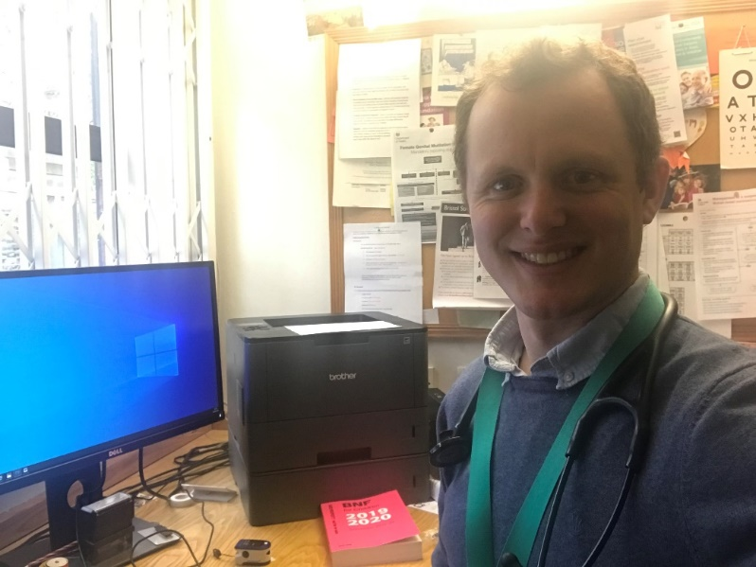**Mark Ashton PA-R** (class of 2018)

Montpelier Health Centre, Bristol – “My typical day:

10:00 – 13:30 Morning clinic 10 patients, mixture of same day and 2-week pre bookable appointment, dealing with a range of acute and chronic presentations, all 15-minute appointment, telephone calls following up for patients already seen in the previous couple of weeks. Currently see a wide range of presentations and age groups, ranging from paediatrics to geriatrics.

13:30 – 15:00 After morning clinic I have 1 home visit slot, this tends to be filled most days, interpretation, filing and contacting patients regarding laboratory results or radiology investigations, writing referral letters, reviewing hospital discharge letters, responding to tasks from other members of the team.

15:00 – 17:30 – Second clinic 10 patients, again mixture of same day and 2-week pre bookable appointments.

17:30 – 18:00 – Late home visit slot, or an extra 2 urgent face to face appointments, or helping the on-call GP with phone calls.”

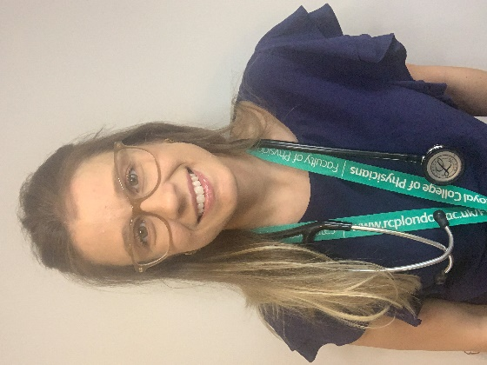**Mariana Pasquali Godoy PA-R** (class of 2019)

St Augustine’s Medical Practice, Bristol

“I have been working in primary care since January 2020, having been the first PA to be employed by the surgery. I work under the supervision of different GPs and I have a designated GP mentor as well.

My clinics are mainly 'on the day' slots, which means I tend to see more acute problems, although this can sometimes be hard to triage and I end up seeing quite complex chronic cases.

My appointments alternate between 20 and 30 minutes long during a 4-hour surgery and I have two designated slots for discussion with the supervisor if needed. This means I see 8 patients in each of my surgeries. This was the arrangement until the coronavirus outbreak when I had to start working from home. The idea was to reduce all my appointments to 15-20 minutes allowing me to see a few more patients. This will have to be done when the outbreak resolves.

Within the practice, my surgery allows the GPs to have more slots available for their follow-ups, telephone appointments and other more complex patients because they can share with me the 'on the day' cases. I think this has had a good impact on the surgery and patient satisfaction as it allowed a higher number of urgent slots to be available. I also have two hours of tutorial with joint observed surgery every week.”