HEE Star Training

Introduction

The HEE Star has two functions as an online directory and an OD framework to structure workforce conversations.

To date, Health Education England has worked with providers and ICS systems, using the HEE Star as an OD framework to facilitate Star workshops.

A Star workshop is run by a trained facilitator, working with a group of stakeholders on a defined workforce challenge, determining responsive solutions to overcome that challenge and to deliver the best patient care.

As workshops begin to build momentum across the country, HEE are keen to extend training in this methodology to a wider network of local/regional facilitators and trainers to build further capacity, which will help to support providers in shaping their future workforce redesign activities.

Since October 2020, the Level 2 Star training programme has been successfully delivered to experienced facilitators within ICS/STP’s across the country. However, due to high demand, HEE are now also offering a webinar (Level 1) for those interested in gaining further knowledge about the HEE Star.

Levels of HEE Star training
The figure below sets out the 3 levels of HEE Star training and distinguishes the most suitable audience for each level.
Further detailed information about each of the levels can be found on the following pages.

Introduction to HEE Star webinar
For those who require an overall knowledge of the HEE Star but will not be required to faciliate a Star workshop.
s
Level 1

Level 2
HEE Star practitioner training programme
For experienced facilitators or those who will be facilitating Star workshops as part of their role.
NB: There is no requirement for these people to attend Level 1 webinar.

Level 3
Train the Trainer
For those who have attended the Level 2 training programme, facilitated a Star workshop and want to now train others in their organisation or system to become HEE Star practitioners (using the Level 2 training guidance).
s

Level 1 - Introduction to HEE Star webinar
Course overview: A virtual webinar to introduce the HEE Star methodology including:
- Overview of Workforce Transformation
- Origins and functions of the HEE Star
- Key enablers of workforce change
- 5 step approach to planning and delivering a HEE Star workshop
- Previous workshop examples
- Discussion
Pre-requisites: A commitment to workforce redesign and improving the quality of patient care
Audience: HEE staff, NHS Trusts, CCG’s, ICS systems who need a baseline knowledge of the HEE Star methodology.
These people may be interested in understanding the model generally or may be supporting HEE Star trained colleagues to introduce or promote the Star model. However, they will not be required to facilitate Star workshops.
Duration: 1 hour
How to book: Please complete our booking form to express your interest and we’ll be in touch shortly to confirm your place.

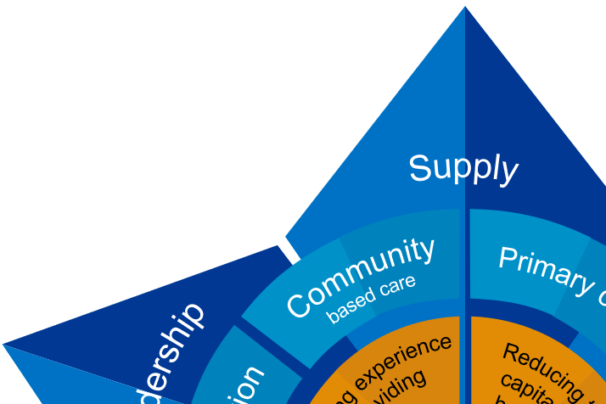

Level 2 - HEE Star Practitioner Training Programme
Course overview: This training programme will focus solely on using the HEE Star as an OD framework. It will equip participants with the knowledge and skills to design and deliver a workshop in relation to a specific workforce challenge, supporting subsequent development of workforce transformation plans.
The programme will include:
- Training session 1: 5 steps to planning and delivering a Star workshop
- Training session 2: Practical application of the HEE Star methodology with a local workforce challenge
- Observation of a HEE Star workshop facilitated by a trained practitioner.
- Facilitation of local workshop
Audience: Those working in roles that include workforce redesign/transformation, HR or Organisational Development. You must be either an experienced facilitator or will be required to facilitate as part of your role.

Pre-requisites: Trainees should be able to evidence:
- Commitment to workforce redesign and improving the quality of patient care
- Knowledge of workforce constraints and drivers over a 3-year horizon
- Confident facilitation and consultancy skills
- Thought leadership and influencing skills at system level
- Experience of delivering and evaluating training
- Experience of working with senior clinicians and managers
- Ability to demonstrate professional credibility
- Clear support from their line manager and can commit both time and effort to the preparation and delivery of HEE Star workshops.

Duration:
Session 1: 2.5 hours
Session 2: 3 hours
Observation: Access to a video recording of a workshop or observing a live, virtual workshop (5 hours)
Facilitation: Preparation, planning and facilitation of a Star workshop, with ’buddy’ support from the national Workforce Transformation team

How to book: Please contact transformation@hee.nhs.uk to express an interest and a booking form will be shared for completion.

Level 3 - Train the Trainer
Course overview: This course is designed to equip attendees with the skills, knowledge and resources required to then train other colleagues in becoming a HEE Star practitioner.
Audience: Those who have completed the full Level 2 Star training programme and are working in roles that include workforce redesign/transformation, HR or Organisational Development.

Ideally, you must have some experience of delivering training and/or willing to train and support others in the HEE Star methodology.

Pre-requisites: Trainees should be able to evidence:
- Completion of full Level 2 training programme
- Experience of preparing, planning and delivering a HEE Star workshop
- Experience of delivering and evaluating training
- Commitment to workforce redesign and improving the quality of patient care
- Knowledge of workforce constraints and drivers over a 3-year horizon
- Thought leadership and influencing skills at system level
- Ability to demonstrate professional credibility
- Clear support from their line manager and can commit both time and effort to the delivery of HEE Level 2 Star practitioner training, including supporting trainee practitioners with future facilitated workshops.

Duration: 4 hours
How to book: HEE Star practitioners who have completed the full Level 2 training programme will be offered the opportunity to attend the Train the Trainer session by invite only.

