Student Placement Supporting Information – General Practice Nurse

Kate Stratton and Carly Hemmings
Non-GP placement Fellows for BNSSG Training Hub

Content

Introduction

Supporting, Supervising and Assessing Nursing Students in Practice
New Placement provider Guide

Example Induction Pack

Audit Information

UWE Information

PebblePad Support

Arc Support

Clinical Education Models
Placement Initiatives
Learning Organisations

Day Visit Options for Students
Payment Information
Other Useful Information

Introduction
Hosting student nurses in general practice can feel challenging, particularly for practices that are new to providing placements. Establishing the necessary processes, understanding placement requirements, and knowing where to access support can sometimes feel overwhelming.
Following the results of our recent survey, we identified several areas that practices felt made student placements more difficult to organise and manage.
This guide has been developed to support practices at every stage of the placement journey. It provides practical information on becoming a placement provider, the documentation required, clinical education models, available funding, and key contacts who can offer advice and support.
Expanding student nurse placements within general practice directly supports the ambitions of the NHS 10 Year Health Plan, which sets out a vision for delivering more care closer to people's homes through integrated, multidisciplinary neighbourhood teams. As primary care plays an increasingly central role in prevention, early intervention and the management of long-term conditions, developing a skilled and sustainable workforce is essential. By providing high-quality placement experiences, practices help prepare the future workforce to deliver collaborative, community-based care that meets the needs of local populations and supports the continued development of neighbourhood health services.
We are incredibly grateful for your continued commitment to supporting student nurses. By hosting placements, you play a vital role in increasing placement capacity, developing the future general practice nursing workforce, and ensuring primary care is equipped with the skills professionals need to deliver the ambitions of the NHS for years to come.
Kate and Carly
BNSSG Non-GP Placement Fellows
Bnssg.th.placements@nhs.net

Supporting, Supervising and Assessing Nursing Students in Practice

Registered nurses supporting student nurses in practice must be appropriately prepared for their role as Practice Supervisor or Practice Assessor in line with the Nursing and Midwifery Council (NMC) Standards for Student Supervision and Assessment. UWE Bristol recommends completion of the Supporting Students in Practice programme for nurses who have not previously undertaken recognised mentorship or practice education preparation, while those with existing mentor preparation should complete the relevant Standards for Student Supervision and Assessment (SSSA) update requirements.

Initial Course- Supporting Students in Practice (SSIP)
The SSIP is a UWE Bristol preparation programme designed to help registered healthcare professionals develop the knowledge and skills needed to support nursing students in practice placements. It aligns with the NMC Standards for Student Supervision and Assessment (SSSA) and prepares staff to undertake roles such as:
- Practice Supervisor – supporting, guiding and facilitating students’ learning experiences in clinical practice.
- Practice Assessor – making objective decisions about whether a student has achieved the required proficiencies and learning outcomes (where the practitioner meets the relevant criteria).

Supporting Students in Practice - Professional/Short course - UWE Bristol: Courses

Annual Update

If you have already completed a mentorship qualification (such as FLAP or 997/998), you are expected to complete the SSSA transitional update and then undertake annual updates rather than the full course.

- Book a Nursing annual update and attend a virtual SSSA update facilitated by experienced Academics in Practice. We will normally send a confirmation of your booking within five working days.
- View the Nursing annual update presentation (PPTX) 11.5MB

Standards for student supervision and assessment (SSSA)
The Nursing and Midwifery Council (NMC) student supervision and assessment (SSSA) (NMC, 2018).
The SSSA (NMC 2018) is applicable to all new and existing nursing associate, graduate nursing programmes.
- Fact sheet of changes to support practice (PDF)
- Nursing SSSA support (PDF)
Become familiar with SSSA and refresh your knowledge of supervising and assessing students in practice with the SWAY package:

Nursing SSSA SWAY package

New Placement Provider Guide

What is the process for becoming an approved placement (practice learning environment), and what are the key steps involved?

- The Practice Academic Team Lead (PAT) initially reviews the placement provider’s details to ensure all necessary information is accurate and complete.

- A PAT Lead or Academic in Practice (AiP) then meets with the provider to discuss requirements. This includes confirming that there is at least one registered nurse available to undertake the Practice Assessor role, reviewing UWE and placement expectations, etc.

- During this discussion, the suitability of the learning environment is explored, including available learning opportunities aligned to NMC proficiencies and programme outcomes, as well as which fields of nursing the provider can support.

- UWE also reviews the provider’s CQC inspection reports to inform discussions ahead of the audit.

- Following this, the university contacts the Professional Practice Office to initiate the formal process. This includes completion of a new placement request form and a workplace agreement, which must be submitted at least two weeks prior to the planned audit visit.

How long does the approval process typically take from initial enquiry to hosting students?

The approval process typically takes a minimum of two to four weeks from initial enquiry to a placement being ready to host students. However, this timeframe can be extended depending on the availability of the placement provider and the UWE Practice Academic Team Lead or Academic in Practice to undertake the required audit and approval processes.

What documentation, governance processes, or audits are required?

Key requirements include:

- Students must have access to relevant local placement policies and procedures to support safe and effective practice.
- A practice learning environment audit is undertaken to ensure the setting meets the Standards for pre-registration nursing programmes - The Nursing and Midwifery Council and Standards for student supervision and assessment - The Nursing and Midwifery Council.

- The audit process evaluates whether the learning environment can provide suitable opportunities for students to achieve required NMC proficiencies and programme outcomes.

- Nursing staff involved in student support must be appropriately prepared for their roles, including completion of SSSA training. Supporting Students in Practice - Professional/Short course - UWE Bristol: Course

- Practice supervisors and assessors are also required to attend mandatory annual updates provided by the university to maintain their role competency. Nursing annual update.

Once approved, is this a one-time process, or are there ongoing approval or review requirements to maintain placement status?

At the University of the West of England (UWE Bristol), nursing placement areas undergo an initial educational audit when newly set up, followed by self-assessment and re-auditing by placement providers at regular time intervals in alignment with Nursing and Midwifery Council (NMC) standards.

Examples of Induction Pack

Student Nurse Induction Pack (.docx)

Student induction pack - Orchard (.docx)

BNSSG generic introduction booklet (.docx)

Audit Information

Initial audit
An initial audit is required for all new placements and is jointly undertaken by a UWE Bristol representative and by a practice placement partner. Initial audits are now done online, please see guides below.
- UWE Bristol Placement setup and audit process for new and continuing placements (PDF)
- Example audit (PDF)

Audit Reviews
Placements are re-audited every two years, either by the placement provider independently or jointly with a UWE Practice Academic Team Lead or Academic in Practice, to ensure continued compliance with NMC standards and the provision of a high-quality learning environment.

Self-assessment audit
Self-assessment audits are required for all existing placements, in the process of re-auditing a placement. This is completed by the placement provider at regular time intervals. It is then disseminated appropriately at all levels to ensure learning from good practice.

Audit system
The UWE audit system on the website is now live and available to all existing web users. It can be accessed using your current work email address and password. To carry out an audit you will need editing permissions, so please visit log in to ARC Single Sign On (placement profile and audit).

New web users can contact an academic practice lead for their practice area, with queries about using the web systems. For those not yet using the system, you will be provided with a login on completion of the new placement and/or web users request form (DOC). See our ARC guides and forms web page for more guidance.

UWE Information


The University of the West of England (UWE Bristol) is the principal higher education provider of pre-registration nursing education for primary care across Bristol, North Somerset and South Gloucestershire (BNSSG), supplying the majority of locally trained student nurses through its education and placement partnerships with primary care providers.

Practice Support Website
Practice Support Net - Colleges and Schools | UWE Bristol

Raising Concerns about a Student
Raising concerns - Practice Support Net | UWE Bristol

UWE Student Policies and Procedures
Policies and procedures - Practice Support Net | UWE Bristol

UWE Contacts
Practice support contact- 0117 32 81152 or hscpsl@uwe.ac.uk
Practice absence reporting- 0117 32 83283 or practiceabsence@uwe.ac.uk
Marcia May- Practice Academic Team Lead (BNSSG)- marcia.may@uwe.ac.uk
Programme support generic email- HSCPSL@uwe.ac.uk

PebblePad Support


PebblePad is a personal development and assessment platform that provides students with an electronic workbook. This workbook may also be known as a portfolio, clinical skills handbook or similar.
Workbooks have a similar feel to an online form, where students and assessors can fill in sections and read key information.
Both you and your student will have access to the same workbook through your separate PebblePad accounts. You will have different permissions in the workbook, so you can fill in the right sections.
As you and your student fill in sections and save, the live workbook will update in real time. UWE staff with the appropriate permissions will also be able to view the live copy.

PebblePad guide for external assessors
PebblePad Guide for External Assessors - PebblePad Guide for External Assessors

PebblePad Example
Pebble+ Public asset view - (Sept 2025) BSc Nursing Workbook

Live Demonstration Pebble pad Workbook.

Arc Support

ARC is UWE Bristol’s placement management system. The ARC suite consists of ARC POW (for students), ARC PEP and Audit (for placement providers) and ARC Timesheets (for placement mentors).

ARC guides and forms - Practice Support Net | UWE Bristol

Download ARC PEP guides:
- System guide (PDF)
- Placement profile guide (PDF)
- Placement profile guide - Social Work only (PDF)
- View allocated students guide (PDF)
- Reports guide (PDF)
- Student allocation report guide (PDF)
- Next audit due report guide (PDF)
- Upload documentation guide (PDF)
- Add educators to the ARC PVI register guide (for trust contacts) (PDF)
- Request a new placement profile: ARC PEP and Audit: New Placement and Users Request Form
- Request new user access to ARC PEP and Audit or make changes to existing users or placements: ARC PEP and Audit: New User or Amend a User/Placement Request Form

Clinical Education Models

A clinical education model is a structured approach used to organise and deliver learning within a healthcare practice environment. It outlines how students or trainees are supported to develop clinical knowledge, skills, professional behaviours, and confidence while providing patient care under appropriate supervision. Placement providers can combine different clinical education models to create a flexible, high-quality learning experience that meets the needs of students, supervisors, and the placement setting.

- Collaborative Learning in Practice (CLiP): Collaborative Learning in Practice (CLiP) is a widely used model designed to enhance student placement experiences through peer-to-peer support across year groups. While care remains under the supervision of a practice supervisor or assessor, students take the lead in organising and delivering it, offering a hands-on, realistic experience that builds confidence, leadership, and clinical skills. The model also integrates the wider ward team into the learning environment, exposing students to various roles such as reception, estates, and other clinical professionals. A key benefit is its ability to deliver high-quality supervision and coaching within existing staffing constraints.

- Long-arm supervision (indirect or off-site supervision): Long-arm supervision refers to a model where the registered professional supervisor is not physically present full time in the placement setting but retains responsibility for student supervision and assessment remotely or through scheduled contact. Day-to-day support may be provided by non-registered staff or another team member

- Role-emerging placements: These are placements in settings without an established professional role, often linked to long-arm supervision i.e. care homes, charities, schools and community organisations

- Peer-assisted learning (PAL): Students learn collaboratively in pairs or groups rather than under exclusive 1:1 supervision. Learners support each other's development through shared learning, feedback, teaching and reflection.

- Hub-and-spoke models: The hub and spoke model is a clinical placement framework where a student is assigned to a primary healthcare setting (the hub) for the majority of their training, while also taking short, complementary visits to other departments or community settings (the spokes) Learners have a main placement (hub) alongside shorter experiences (spokes) in related settings to gain a broader understanding of care pathways.

- Dedicated Education Units (DEUs): Clinical areas specifically designed for student learning, where healthcare providers and education institutions work together to deliver high-quality placements.

- Practice assessor/practice supervisor models (post-NMC 2018 standards): Practice supervisors support learners in practice, while separate practice assessors independently evaluate their achievement of required proficiencies.

- Apprenticeship and coaching models: Work-based learning approaches that combine employment with structured education, using coaching and supervised practice to develop competence.

- Interprofessional learning placements: Placements where learners from different health and social care professions learn with, from and about each other to strengthen collaborative practice and improve patient care.

Placement Initiatives

Safe Learning Environment Charter (SLEC)

NHS England » Safe Learning Environment Charter
The Safe Learning Environment Charter (SLEC) is a national initiative developed by NHS England to create positive, inclusive, and supportive learning cultures for healthcare students and trainees. It establishes clear expectations and a framework to ensure that everyone learning and working in the NHS feels valued, respected, and psychologically safe
The framework is built around 10 core principles that define what a "good" learning and working environment looks like:
- Respect and feeling valued
- Positive identity
- Wellbeing
- Raising concerns & speaking up
- Placement induction
- Communication
- Flexibility
- Supervision
- Teaching and learning needs
- Time and space for learning

NHS England Education Quality Strategy and Framework

Education Quality Strategy and Framework | NHS England | Workforce, training and education
The NHS England Education Quality Strategy and Framework is the overarching national system used to monitor, evaluate, and continuously improve the quality of healthcare education and training across all clinical placement environments

Core Focus Areas
The framework is designed around several non-negotiable principles that all placement providers must follow:
- Patient Safety & Learner Wellbeing: Placing the safety of patients and the psychological and physical wellbeing of students at the heart of all training.
- Multi-Professional Approach: Applying a unified set of quality standards across all healthcare fields, including medicine, nursing, midwifery, and allied health professions.
- Equality, Diversity, and Inclusion (EDI): Ensuring that clinical environments promote equity and are entirely free from discrimination.
- Continuous Quality Improvement: Using direct data and active interventions to fix placements that fall short of national standards.

Learning Organisation

A Learning Organisation is a group of practices - ideally based upon a Primary Care Network (PCN) footprint - that is approved on behalf of the practices within it, to host multi-disciplinary learners. The purpose is to streamline the process of reapproval visits by reducing the number of reapproval visits and audits required and focusses on ensuring compliance with the 6 domains of the NHSE Quality Framework.
Historically, each practice that supported learners had to undergo regular visits and audits for each profession they supported. By being part of a Learning Organisation, there is a single annual review of the Learning Organisation that approves all learners and sites within that Learning Organisation.
Practices aligned with a PCN that has been approved as a Learning Organisation may differ from the total number of practices within a PCN.

- Learning Organisations - BNSSG Training Hub
- Primary Care Learning Organisation Toolkit - Working across the South West
- Primary Care Learning Organisation FAQ’s - Working across the South West

Day Visit Options for Students

Heart Failure team
- Sirona Heart Failure 0117 9617153
- Sirona.heartfailureservice@nhs.net

Cardiac Rehabilitation team
- 0117 4140040
- Cardiacrehab@nbt.nhs.uk

Pulmonary rehabilitation
- sirona.respiratory@nhs.net

Diabetes and Nutrition services
- sirona.dans@nhs.net
- 0300 1245908

Drugs and Alcohol misuse service (area dependent)
- Bristol Drugs Project- BDP (Bristol) info@bdp.org.uk
- Developing Health and Independence- DHI (South Glos) info@dhi-online.org.uk
- We are With You (North Somerset) 01934 427940

End of life
St Peter's Hospice
- Healthcare Placements - St Peter's Hospice
- Professional Visitors - St Peter's Hospice

Podiatry
sirona.podiatryadvice@nhs.net

Wound care Team
- Sirona.wcs@nhs.net
- 0117 9449733

Lymphoedema Team
- Sirona.lymphoedemateam@nhs.net
- 01275 547573

School Health Nurses
- Bristol- 0300 1245816 sirona.bristolschoolnursing@nhs.net
- North Somerset- 03001256798 nsomerset.schoolnurses@nhs.net
- South Gloucestershire 03001255151

Sexual Health (Yuno)
- 0117 9290090

The Haven- Health Service for Asylum Seekers and Refugees
- The Haven – Sirona care & health NHS services
- 03001246875
- The.haven@nhs.net

Health Links- service for people in Bristol who have English as a second language and have difficulty in accessing health services due to language and cultural barriers
- Health Links – Sirona care & health NHS services
- 0117 9027115
- Healthlinks@nhs.net

Payment Information
Education and training tariffs 2025 to 2026 - GOV.UK
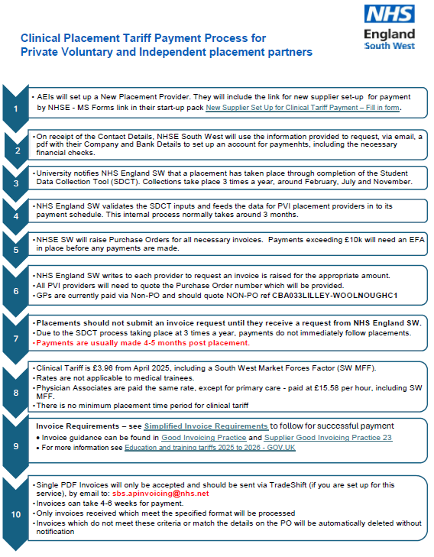

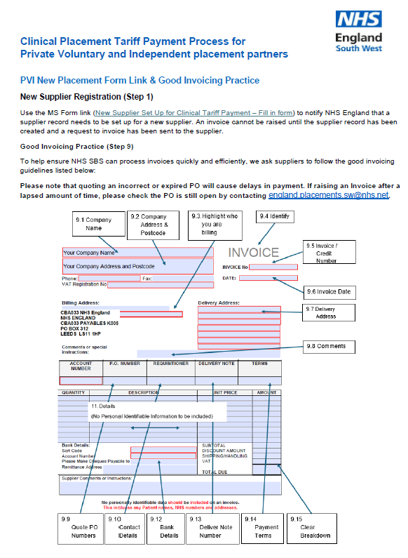
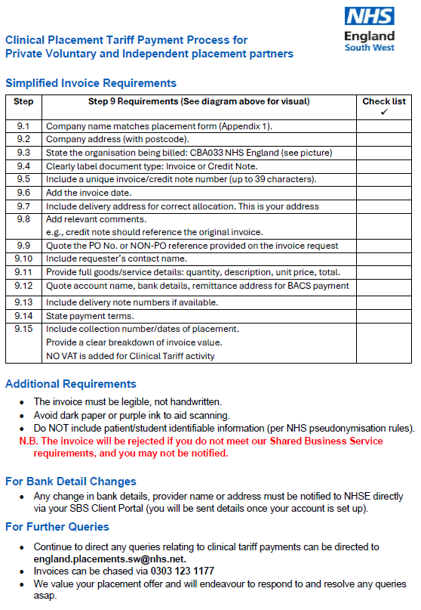

Other Useful Information

- NMC Standards for student supervision and assessment- Standards for student supervision and assessment - The Nursing and Midwifery Council
- Busting the myths on general practice placements | RCN Magazine | Royal College of Nursing
- Nurse placement ‘barriers’ in GP practices ‘concerning’ for future workforce | Nursing in Practice
- Welcome to the Student Nurse Hub | NHS England | Workforce, training and education
- Student placements in the NHS | NHS Employers
- Student Nursing | NHS Professionals
- NHSE Workforce, training and education - Student Nurse Hub
- Home (Remedy BNSSG ICB)
- Educator Workforce Programme - Futures

