**Patient Satisfaction Questionnaire (PSQ)**

|  |  |
| --- | --- |
| **NAME OF PRACTITIONER:** |  |
| **DATE :** |  |
| **LOCATION:** |  |

**Please tick your response**

1. 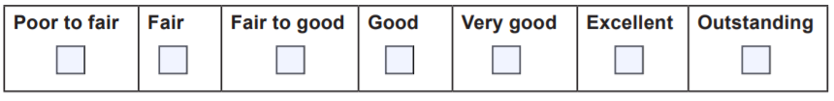Making you feel at ease (being friendly and warm towards you, treating you with respect, not cold or abrupt)
2. Letting you tell “your” story… (giving you time to fully describe your illness in your own words, not interrupting or diverting you
3. Really listening… (paying close attention to what you were saying, not looking at the notes or computer as you were talking).
4. Being interested in you as a whole person… (asking/knowing relevant details about your life, your situation; not treating you as ‘just a number’).
5. Fully understanding your concerns… (communicating that he/she had accurately understood your concerns; not overlooking or dismissing anything).
6. Showing care and compassion… (seeming genuinely concerned, connecting with you on a human level, not being indifferent or ‘detached’).
7. Being positive… (having a positive approach and a positive attitude, being honest but not negative about your problems).
8. Explaining things clearly… (fully answering your questions, explaining clearly, giving you adequate information, not being vague).
9. Helping you to take control… (exploring with you what you can do to improve your health yourself, encouraging rather than ‘lecturing’ you).
10. Making a plan of action with you… (discussing the options, involving you in decisions as much as you want to be involved, not ignoring your views).
11. Overall, how would you rate your consultation today?

**Many thanks for your assistance**