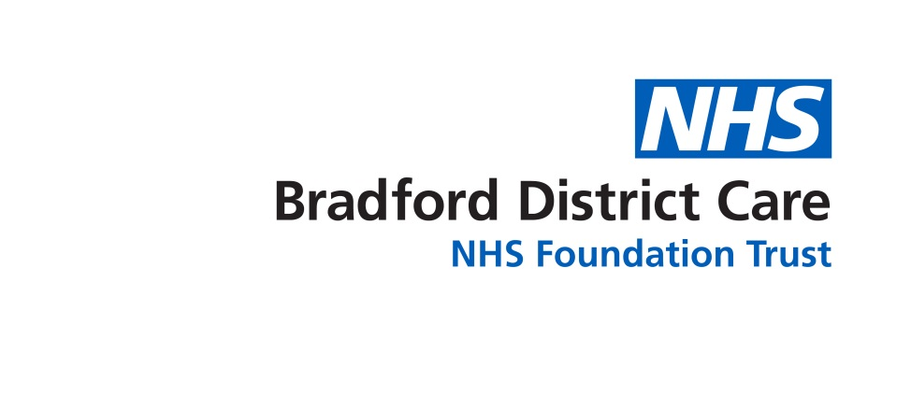

Mental Health Occupational Therapy in Primary Care:

The potential for GP practice in Wharfedale, Airedale and Craven

Bradford District Care NHS Foundation Trust

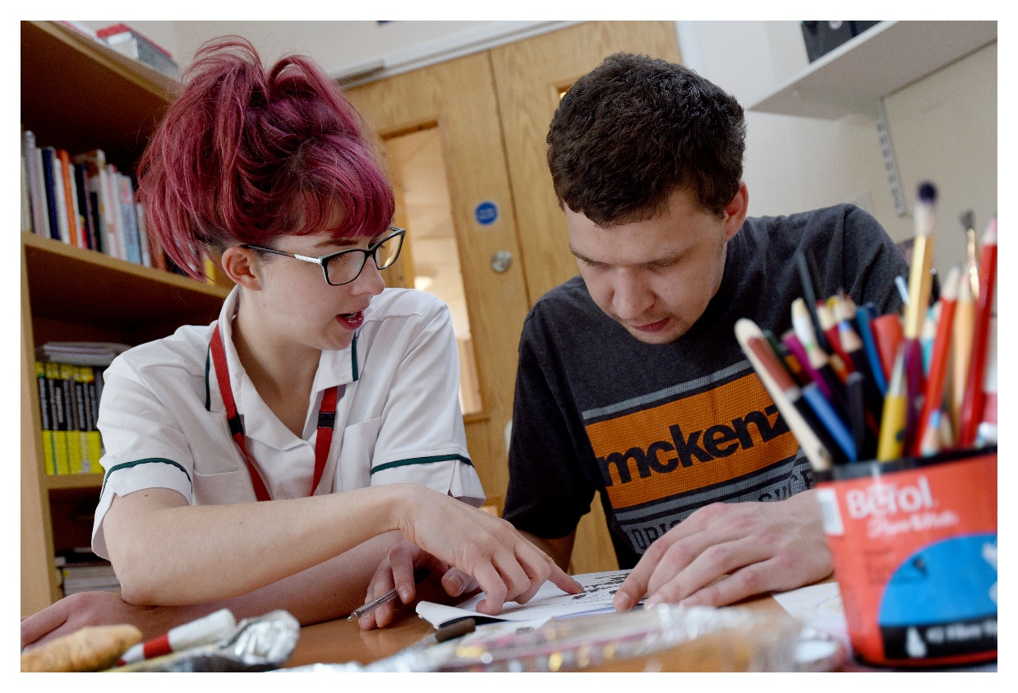

Cathy Wright

Allied Health Professions Lead

Bradford District Care Foundation Trust

August 2020

**Introduction and Background**

The emphasis for enhancing Primary Care is set out in the Long Term Plan (2019) with the requirement for enhanced community-based care and a focus on building capacity and capability within community services for early intervention and prevention of ill-health and supporting people to manage their own health and long-term conditions. Within this agenda is the investment in new roles and an inter-disciplinary workforce with the flexibility to support people with a range of needs as close to home as possible. For mental health, this included a major expansion to the mental health workforce and more integration between physical and mental health, with co-location of practitioners in primary care and mental health staff aligned to primary care networks. Arising from this is the publication of Investment and Evolution: A five-year framework for GP contract reform and implement the Long-Term Plan (NHS England 2019) set out the plans for investment in new additional roles to expand the multi-disciplinary teams within primary care including Allied Health Professions roles such as physiotherapy and podiatry, alongside roles for community pharmacy and social prescribing. This framework was updated and expanded in February 2020 (NHSE 2020) to include investment in Occupational Therapists and Mental Health Practitioners.

This paper presents an outline model for Mental Health Occupational Therapists within Primary Care in Wharfedale, Airedale and Craven.

**Primary Care and Mental Health: a role for Occupational Therapy**

Occupational Therapists’ (OTs) core focus is to help people carry out all occupations of daily life and to enable people to do the things they want and need to do, and to live as full and independent lives as possible. They support people of all ages with problems resulting from physical, mental, social, or developmental difficulties. Being dual trained in physical and mental health, with experience across all ages and in acute, community, local authority services and the independent and voluntary sector, OTs offer am integrated bio-psychosocial approach well-aligned to the needs of primary care. OTs support people to find ways to continue with the everyday activities that are important to them, which could include learning new ways to do things or making changes to their environment. As patients’ needs are varied, OTs can help in primary care supporting people who are frail, with complex needs, those living with chronic and long term conditions, managing common mental health conditions such as anxiety and depression, providing support for people to return to or remain in work and for those who need rehabilitation to continue with their activities of daily living (Royal College of Occupational Therapy 2015). Studies of pilot projects already in place within primary care are showing the value of occupational therapy within this setting. Results from a local pilot project in Leeds demonstrated that the integration of OTs into primary care has the potential to reduce pressure on GPs, lessen referrals to secondary services, positively impact on mental health and keep people well and independent at home (Brooks, Milligan and White 2017). Another study by Locas et al (2019) reported on how GPs considered OTs to effectively meet the many of the diverse needs people present with in primary care and improve the overall quality of primary care services.

**The local context: how OT roles in Primary Care could add value in Wharfedale, Airedale and Craven**

Wharfedale, Airedale and Craven covers an area with a wide and diverse demographic both in the population, the geography, and the socio-economic needs across its communities. Data from the Health and Wellbeing Profile 2020 (Bradford City and Bradford Districts Clinical Commissioning Groups and Bradford Metropolitan Council) summarises the main needs for:

* Wharfedale – An area of approximately 44,130 people, Wharfedale has a higher than average older population, with 26.4% of people aged over 65. This area is the least deprived in the Bradford district, with people on average experiencing better health, lower levels of mental health issues, smoking and obesity. However, there are higher numbers of people with dementia and multiple morbidity than in other parts of the district and with the ageing population, increasing frailty.
* Airedale – An area of approximately 67,700 people and a more ethnically diverse population with 20% of people identifying as BAME. In comparison to Wharfedale and Craven, Airedale has a young population, with 23.8% being under 18 and 58.8% being of working age 18-65. There are higher levels of socio-economic deprivation and health related consequences, and higher than district average numbers with obesity related problems and also of people with mental health issues. Whilst numbers of older people are lower than in Wharfedale and Craven, there is increasing age-related frailty.
* Craven – An area of approximately 44.400 people and a higher older age population. Craven has lower levels of deprivation in comparison to other areas in the district, higher than average life expectancy and lower rates of obesity and smoking. However, with an ageing population is a higher prevalence of people with long term conditions and dementia, age associated frailty and higher numbers of people who have caring responsibilities. The rurality and large geographical spread of Craven also brings its own challenges in terms of transport networks and access.

Additional to this are the added challenges from Covid-19 and the impact of the pandemic across the population, both for physical and mental health due to the specific consequences for Covid survivors, vulnerable and shielding groups and for all those whose lives have been displaced as a result.

OTs have the integrated skills and are well-placed to respond to the diverse universal, targeted and specialist needs of people presenting within Wharfedale, Airedale and Craven and to provide high quality and innovative patient centred care in line with the values and vision that the Wharfedale, Airedale and Craven Alliance.

Different studies have listed and suggested the specific ways that OTs can work in primary care and make a difference which include:

* Working with children and adolescents – supporting with diagnosis clarification such as with ADHD or Autism, screening and early intervention, functional and developmental assessment and interventions targeting parents and teachers. Within Airedale, Wharfedale and Craven this could be supporting work of school nursing or primary care mental health workers within Child and Adolescent Mental Health Services.
* With working age adults – supporting with people with mental health, anxiety and mood disorders with recovery, relapse prevention, supporting return to work, improving lifestyle and occupational balance, interventions to improve functioning in everyday activities, teaching stress management strategies, and providing group interventions focused on recovery, based on activation and cognitive behavioural strategies. Within Airedale, Wharfedale and Craven, the OT would work to build pathways with community health colleagues, linking with My Wellbeing College, mental health services and voluntary sector services and supporting social prescribing.
* With older adults – supporting people with frailty, falls and functional decline, with neuro-cognitive impairment and end of life care, screening and assessing functional difficulties, helping people maintain independence and safety at home, provide home and environmental adaptations and driving assessments. For mental health, OTs can help older people with mental health issues, anxiety, and low mood, enabling people to maintain daily occupations, and address difficulties such as social isolation and loneliness. Within Airedale, Bradford and Craven, the OTs would work to build links with community health and therapy services, older peoples mental health, voluntary sector and social prescribing and supporting assessments for services such as memory clinics.
* Other areas, where OTs can add value are with people with chronic pain or musculoskeletal conditions, helping with returning to work and workplace assessments, with pain and lifestyle and activity management strategies and linking with community therapy and specialist services.
* Supporting with on-going staff training and interdisciplinary development across primary care and providing support and supervision for social prescribers.

(Brooks, Milligan and White 2017; Brooks and Thew 2020, Dahl-Popolizio et al 2017, Locas et al 2019; Orman 2018, McCabe and Greer and NHS Scotland 2020, and Phillips and NHS and Public Health Wales 2020)

**Mental Health OT Roles and WACA: considerations for implementation**

When considering how these roles can work there are many questions to consider in order to develop a successful model of delivery. These include where roles will be based, how they will work and what workforce skill mix options are there to gain the most benefit, what governance arrangements, supervision and training needs will there be to ensure practitioners have the right skills to deliver quality care, and what agreements are needed around staffing and employment for the service to work effectively and safely for WACA and for the clinicians involved.

Where and how will OTs work?

WACA covers eight independent GP practices in Addingham, Skipton, Ilkley, Keighley and Settle, with a broad geographical spread. There will need to be consideration about where roles will be based across the locality, and whether OT practitioners work independently of each other, integrated within and taking referrals from individual practices, or are based together, as an |OT hub team, with the flexibility to work across practices according to need, and with OTs aligned to practices but taking referrals collectively and allocating to match patient needs with practitioner skills.

How OTs will work will need consideration to ensure that WACA gain the most from the provision. The focus of work could be to address: *universal needs* by providing OT advice on self-management that is readily available and accessible to the whole patient population, *targeted needs* with brief intervention for those who can self-manage but need some extra time to support daily living skills and underlying problems, or *specialist needs* for people who have the most complex needs, requiring a range of support and partnership working with other professionals and linking into specialist care pathways.

Occupational therapy pathways will need to be agreed which define appropriate patients who can be seen and how these will link with more specialist community and secondary care pathways when more on-going and

As with other community practitioners, in the context of Covid-19, OTs are well skilled in delivering care virtually and developing digital health alongside face to face working, to offer choice and accessibility for patients and flexibility for delivery of care.

What workforce skill mix will best meet WACA’s needs?

It is recommended by the Royal College of Occupational Therapy (2018) that if lone working within and across practices primary care OTs would be expected to work at Band 7 Agenda for Change, with the specialist skills to be able to develop and deliver care effectively. Practitioners in lower bands can be considered if they are working within a multi-disciplinary team and have appropriate governance and support. As these roles will be new for WACA it will be essential to have OTs at the right band with the specialist skills and knowledge needed to develop this service. The proposed funding for development of these posts is £210,000pa and there are different skill mix options WACA may wish to consider.

*Option 1*

4 x 1.00wte Band 7 OTs employed to work across the Alliance. The advantage of this option would be the high skill level to develop a service across the locality and who could work independently across the practices, with the specialist knowledge for diverse needs. However, with costings per wte Band 7 at approximately £53,804, this would be a higher cost, with little flexibility for training and development.

*Option 2*

2 x 1.00wte Band 7, 2 x 1.00wte Band 6 OTs to work as a hub team, with OTs aligned to practices, but working together to pick up referrals and allocate according to needs and skills. The advantage of this model would be that the skill mix would still enable service development and the specialist skills required for primary care needs, but there would also be the flexibility for allocate referrals more effectively and make the most use out of the skill mix of the team. At a cost of £53, 804 per Band 7 wte and £43,425 per Band 6 wte, with a total cost of approximately £194,458, this model would also offer more opportunity for development within the team to grow skills and knowledge around primary care needs.

*Option 3*

2 x 1.00wte Band 7, 1 x 1.00wte Band 6 and 1 x1.00wte Band 5 to work as a hub team, with OTs aligned to practices, but working together to pick up referrals and allocate according to patient needs and practitioner skills. The advantage of this model would be, as above, to enable service development and having the mix of skills needed for the different patient needs, but it would also offer more opportunity for development. With costings at £53,804 per Band 7wte, £43,425 per Band 6wte and £35,679 per Band 5wte and a total cost of approximately £186,712 there is more scope to invest in the development of the team and specialist training for primary care. If considering this option WACA may also wish to consider hosting the band 5 post as a rotational post. There is an established integrated OT Post Graduate Development Scheme, run as a partnership between Bradford District Care Foundation Trust and Airedale NHS Foundation Trust, which offers 16 rotations across physical and mental health and all age services in acute and community care. This rotation scheme enables graduate practitioners to develop integrated skills needs for working across NHS services. WACA would benefit from the different skills and knowledge rotational OTs would bring and their knowledge of and links into different service pathways.

The costings for the above options have been suggested by the finance team at BDCFT to supply OTs for WACA on a service level agreement. These costs include governance arrangements for supervision and development.

Job Descriptions and Person Specifications for these roles can be developed. Examples from other Primary Care Networks are included in the appendix.

What governance arrangements are needed?

As a small group of professionals working across WACA’s community practices, albeit working with other primary care practitioners, there is a need to ensure robust governance, supervision and training to support OTs to work safely and with the right skills for quality care and to prevent risks from professional isolation. Occupational Therapists within Bradford District Care Foundation Trust (BDCFT) are well supported with embedded governance and HR arrangements, to ensure maintenance of professional standards, professional registration, supervision, training, and clinical effectiveness. By providing OTs for WACA, BDCFT can ensure that primary care OTs have access to supervision, training, and development widely available to other BDCFT OTs and that there will be professional lines of accountability to address any arising professional or quality issues. Allied Health Professionals across Bradford, Airedale and Craven have a strong history of collaboration and partnership working between Airedale NHS Trust, BDCFT and Bradford Teaching Hospitals Trust on workforce development and shared training and development and shared practice and knowledge. It is envisaged that OTs employed within WACA and provided by BDCFT would be able to experience the benefits from this collaboration. Having access to this wider professional support network could not only enhance the quality of care but also promote the attractiveness of these new roles for workforce recruitment and retention.

Detailed governance arrangements will need to be agreed between WACA and BDCFT to develop the service specification and service level agreement which also incorporate the practical arrangements for employment, terms and conditions of staff, how the service will be covered and any arising Human Resource issues. BDCFT HR and Business Support Teams can advise on this.

Evaluation and Audit

Lastly, as Mental Health OT roles in Primary Care are new and emerging, and services are in development, there will need to be evaluate the effectiveness and measure outcomes to ensure quality care and best value for money. It is recommended that within the service specification for these roles there will need to be built in plans for auditing the occupational therapy needs of patients presenting within WACA’s practices and detailed evaluation of the service offer in relation to patient needs, usage and outcomes, to determine whether the service is the right fit and to shape its future delivery. Research and evaluation will be essential to understanding the distinct benefits of this service for WACA, building the evidence of what works for the different patient groups, and how to further enhance the service offer. BDCFT has a strong relationship with HEI partners, and for Occupational Therapy there are well established links with Leeds Beckett University and University of Bradford to develop opportunities for research and service evaluation.

**Summary**

This paper has provided an outline description of how occupational therapists can support delivery of integrated primary care within Wharfedale, Airedale and Craven. Mental health occupational therapy is an emerging area of practice within Primary Care, and as such models of practice are being developed and are still in their infancy. However, the integrated skills of OTs and knowledge of working across physical and mental health and with people with a diverse range of needs fits well with the primary care model, to support people to stay well, at home or as close to home as possible and to live their lives as fully as possible.

It has not been the intention of this paper to provide a full detailed model of service as this will need to be developed with the time to fully understand the needs of the patient groups within Wharfedale, Airedale and Craven. It has instead provided an idea of how occupational therapists can work and what they can offer to a primary care team, workforce skill mix options and how BDCFT can support the development of these roles and the governance arrangements needed. BDCFT will welcome further discussions with the board of WACA on further progression on these roles and supporting their implementation.

**References**

Bradford City and Bradford Districts Clinical Commissioning Groups and Bradford Metropolitan Council (2020)

Brooks R, Thew M (2020) (un-published) Occupational Therapy First: Phase 1 Report. A report completed in collaboration with Leeds and York Partnership NHS Trust, Leeds Community NHS Trust, Leeds Teaching Hospitals NHS Trust, Leeds West Primary Care Network and Leeds Beckett University on OT Pilot within GP Practice

Brookes, Milligan and White (2017) Sustainability and Transformation Plans: occupational therapists and physiotherapists can support GPs. British Journal of General Practice, 67(664), 525-526

Dahl-Popolizio S, Rogers O, Muir SL et al (2017) Interprofessional Primary Care: The Value of Occupational Therapy. Open Journal of Occupational Therapy, 5(3), 1-10

Locas V, Prefontaine C, Veillette N et al (2019) Integration of occupational therapists into family medicine groups: Physicians’ perspectives. British Journal of Occupational Therapy, 0(0), 1-11

McCabe S, Greer L on behalf of NHS Lanarkshire, Health and Social Care Lanarkshire and South Lanarkshire Health and Care Partnership (2020) (unpublished and available from RCOT) Occupational Therapy in Primary Care

NHS England (2019) Investment and Evolution: a five-year framework for GP Contract reform to implement The NHS Long Term Plan. (online) available from: <https://www.england.nhs.uk/wp-content/uploads/2019/01/gp-contract-2019.pdf> accessed 25/08/20

NHS England (2020) Update to the GP Contract Agreement 2020/2021 – 2023/2024 (online) available from: [https://www.england.nhs.uk/wp-content/uploads/2020/03/update-to-the-gp-contract-agreement-v2-updated.pdf accessed 25/08/20](https://www.england.nhs.uk/wp-content/uploads/2020/03/update-to-the-gp-contract-agreement-v2-updated.pdf%20accessed%2025/08/20)

Orman K (2018) Primary Care – Why the push from RCOT? OT News, November

Phillips K (2020) On behalf of NHS Wales and Public Health Wales (unpublished and available from RCOT). Occupational Therapy in Primary Care in Mid and West Wales

Information on this service and developing primary care in Wales is available from: <http://www.primarycareone.wales.nhs.uk/occupational-therapists> (accessed 25/08/20)

Royal College of Occupational Therapy (2015) The Contribution of Occupational Therapy to GP Practices London: RCOT available from [www.rcot.org.uk](http://www.rcot.org.uk)

Royal College of Occupational Therapy (2018) First point of contact for Occupational Therapy in GP Practices London: RCOT available from [www.rcot.org.uk](http://www.rcot.org.uk)