**BNSSG Care Coordinator Training and Induction Pack 2025**

Contents

|  |  |  |
| --- | --- | --- |
| Section No. | Section Contents | Page Number |
|  | Introduction to my practice  The Training Hub  What is a PCN?  NHS long term plan  Personalised care  What are the other additional roles? | 3  4  4  5  5  7 |
|  | Helpful contacts from local services  Bristol  North Somerset  South Gloucestershire | 9  9  10  11 |
|  | Training  Role-specific training  Personalised Care Institute  Personalised care training matrix  Paid for training | 12  12  13  13  14 |
|  | Supervision  Models of supervision  Guidance on supervision  Good and bad habits for group supervision | 14  14  15  16 |
|  | Staff wellbeing | 17 |
|  | Additional resources | 17 |

# **Introduction to my practice:**

You will become an important member of your Primary Care Network (PCN) multi-disciplinary team and take referrals from all member practices. You will be supported by a GP supervisor and help your PCN to work differently with people and communities, meeting wider social needs, connecting people for community support.

|  |  |  |  |  |  |
| --- | --- | --- | --- | --- | --- |
| Practice name |  |  |  |  |  |
| Practice manager |  |  |  |  |  |
| Lead admin |  |  |  |  |  |
| Safeguarding adults and children lead |  |  |  |  |  |

# **Introduction**

Welcome to the Bristol, North Somerset, and South Gloucestershire (BNSSG) area, in which we have around 78 general practices serving approximately one million patients.

In BNSSG we share a common belief that primary care is, and should continue to be, the foundation of the NHS.

It is our vision to provide a resilient and thriving primary care service that is the heart of an emerging integrated health and social care system, centred around our patients and carers. We aim to provide a responsive system that delivers needs-based, high quality, equitable and safe care.

People like you are central to that vision, and we are here to support you in your new role. We are delighted to welcome you to the BNSSG team!

We have developed this induction pack to help you integrate with your local primary care network. We hope that it provides you with all the relevant information you require as you embark on your new career path. There is a wealth of further information and support available to help you as you progress in your role.

# **Who are we?**

**BNSSG Training Hub** was launched in 2019 to improve the health, wellbeing and care available to people in BNSSG through strengthening the current and future health and care workforce. With funding from Health Education England (HEE) and other sources, BNSSG Training Hub provides education, training, and career development support to staff working in primary care. To do so, we liaise with education and service providers in the primary, community, social, and voluntary care sectors, from across the Bristol, North Somerset, and South Gloucestershire area and beyond.

# **What is a PCN?**

A Primary Care Network (PCN) is a group of GP practices working more closely together, with other primary and community care staff, and health and care organisations, providing integrated services to their local populations.

From April 2019, individual GP practices have been able to establish or join PCNs covering populations of between 30,000 to 50,000 (with some flexibility). A DES (directed enhanced service contract) supports the development of PCNs and covers several aspects, including funding for the provision of additional workforce roles (the Additional Roles Reimbursement Scheme: ARRS); and services that the PCNs are required to provide.

There are 19 PCNs in BNSSG, for further information please see the following link <https://onecare.org.uk/wp-content/uploads/2021/05/GP-surgeries-in-Bristol-North-Somerset-and-South-Gloucestershire2.pdf>

Please see the following video link for further information about PCNs: <https://www.youtube.com/watch?v=W19DtEsc8Ys>

# **NHs long term plan**

NHSE/I are working on a range of actions to embed personalised care – and in your role as a link worker, you are part of this. These are the six main areas we are working in:

* Supported self-management, especially for people with long term conditions
* Shared decision making between professionals and the people they support
* Social prescribing and community-based support
* Personalised care and support plans
* Choice – over where and how people receive care
* Personal health budgets for people with complex physical needs

# **PErsonalised Care – What is personalised care?**

1. Personalised care is one of the five major, practical changes to the NHS that will take place over the next five years, as set out the recently published NHS Long term Plan. This follows a decade of evidence-based research working with patients and community groups and included the following key changes:
2. Recognises that, for many people, their needs arise from circumstances beyond the purely medical and will support them to connect to the care and support options available in their communities.
3. helps people with multiple physical and mental health conditions make decisions about managing their health, so they can live the life they want to live, based on what matters to them, as well as the evidence-based, good quality information from the health and care professionals who support them

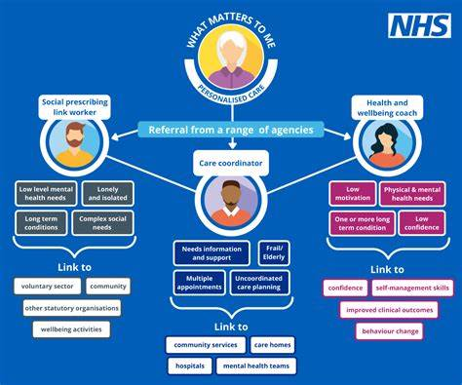

# **What other additional roles may be part of your PCN multidisciplinary team (MDT)**

|  |  |
| --- | --- |
| **Role title** | **Role description** |
| **Care Coordinator** | Care coordinators play an important role within a PCN to proactively identify and work with people, including the frail/elderly and those with long-term conditions, to provide coordination and navigation of care and support across health and care services. |
| **Link Worker (SPLW)** | Link workers give people time, focusing on ‘what matters to me’ and taking a holistic approach to people’s health and wellbeing. They connect people to community groups and statutory services for practical and emotional support. |
| **Health & Wellbeing Coach** | Health coaching is a Supported Self-Management (SSM) intervention and is part of the NHS Long Term Plan. This represents a new relationship between people, professionals and the health and care system. It provides a positive shift in power and decision making that enables people to feel informed, have a voice, to be heard and be connected to each other and their communities. |
| **Clinical Pharmacist** | Clinical pharmacists are primary care health professionals, who work in a patient-facing role as part of a multidisciplinary team (MDT) to clinically assess and treat patients using their specialised knowledge of medicines. They are responsible for medicines optimisation within their respective primary care network (PCN) and conduct clinical medication reviews for patients with complex polypharmacy, especially the elderly, care home residents, or individuals with multiple co-morbidities. |
| **First Contact Physiotherapist (FCP)** | First Contact Physiotherapists (FCPs) are qualified autonomous clinical practitioners who can assess, diagnose, treat and manage musculoskeletal (MSK) problems and undifferentiated conditions and – where appropriate – discharge a person without a medical referral. |
| **Community Paramedic** | As generalists, they can effectively use the medical / biopsychosocial model to assess, examine, treat, and manage patients of all ages, with a variety of undifferentiated and chronic conditions. Their work can involve triaging patients, carrying out telephone and face-to-face consultations, and conducting home visits. They refer patients to GPs for the management of presentations and pharmacology outside their scope of practice. |

# Care coordinator

Care co-ordinators are at the centre of a person’s care. They walk alongside the person and are uniquely placed to see the bigger picture, from clinical care to how their social interactions support their wellbeing.

This diagram shows how a person with complex needs may be getting health and care support from many different professionals, including nurses, counsellors, therapist, activity workers, GPs, surgeons, care worker and managers. Care co-ordinators help link all this care together.

Care co-ordinators take a personalised approach and bring together all the information about a person’s care and support needs. They play a key role in [personalised care and support planning](https://www.england.nhs.uk/personalisedcare/pcsp/) and focus on the [six components of personalised care](https://www.england.nhs.uk/personalisedcare/comprehensive-model-of-personalised-care/). They take a holistic approach, looking at the person, rather than just the conditions they have.

They are skilled in personalised conversations, assessing people’s needs, facilitating joint working, ensuring the effective flow of information, monitoring needs and responding to change.

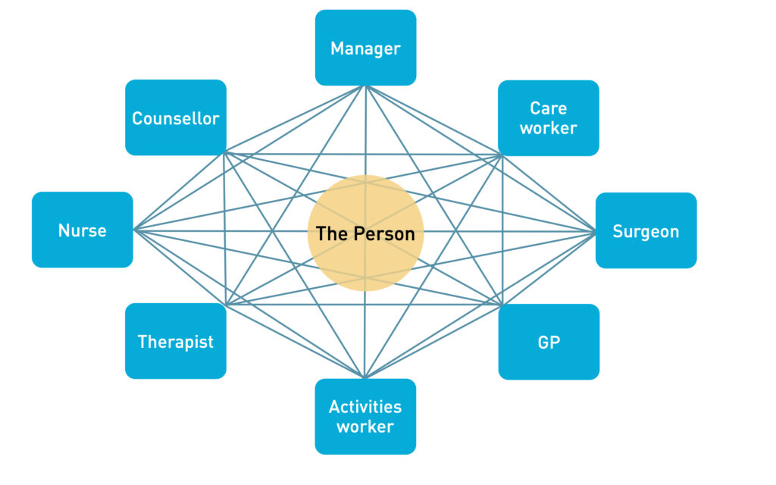

[NHS England » Workforce development framework for care co-ordinators](https://www.england.nhs.uk/long-read/workforce-development-framework-for-care-co-ordinators/)

# **Support at local councils**

# Bristol

safeguarding adult’s referral form

* + - <https://www.bristol.gov.uk/social-care-health/report-suspected-abuse-safeguarding-adults-at-risk>
    - Integrated Carers’ Team
  + Website: [www.bristol.gov.uk/carers](http://www.bristol.gov.uk/carers)
  + Email: [integratedcarersteam@bristol.gov.uk](mailto:integratedcarersteam@bristol.gov.uk)

## Bristol City Council care and support services

* Bristol Shared Lives - Care support provided. Shared Lives is when an approved carer shares their home and family life with a vulnerable adult. Read more about Bristol Shared Lives.
* Disabled Children’s Team (Community care) The Disabled Children’s team provides support at home for children and young people with complex needs, and their families or carers.
* Home First provide short term help, support and assessment of possible future care/support needs over a 7-to-10-day period following a hospital discharge. This could be following poor health, impairment or an accident. Home First also provide access to some therapy support if required as well as aids and adaptations if appropriate.
* Learning Difficulties Supported Living Team. The Learning Difficulties Supported Living Team provides support to people with learning disabilities in their own home.

## Other services available at Bristol city council

* + - First response and Reablement Team
    - Community Meals
    - Homelessness Prevention
    - Homechoice Bristol
    - Learning Disabilities (LD)
    - Disabled children’s service
    - Locality Teams

# North Somerset

* + - Multi-agency professionals. If you are a multi-agency professional, please use the referral form to raise an adult safeguarding concern.
    - <https://www.nssab.co.uk/how-you-can-get-help>
    - Care Connect: 01275 888801 - Monday to Friday 8am ‐ 6pm

## Teams available at North somerset council

* + - Approved Mental Health Practitioners (AMHPs)
    - Assessment and Reablement Team (ART)
    - Care Navigators
  + The Care Navigator Service provides free advice and support to residents of North Somerset aged 18 years and over.
  + The Residents either Financially responsible for their Care and do not want the Local Authority to commission this care on their behalf, or those who do not wish to engage with Adult Social Care to access services to meet their needs.
    - Community Meals
  + The service delivers meals to older and unwell people who have difficulty preparing food and who live in North Somerset.
  + Via telephone Mon-Fri 01275 882 155 or via email community.meals@n-somerset.gov.uk
* Connecting Lives (previously Shared Lives)
  + The Shared Lives service provides support for adults in the carer’s home – in a range of placements: Day Support - for a few hours, a day but not overnight; Respite - support from one night to a few weeks; and living Long Term with a career.
  + The Outreach service provides support for adults in their own home and community – in a range of placements: Day Support - for a few hours, a day but not overnight; Mentor Support - guidance, motivation and role-modelling; and the Sitting Service – enables their family carer to have a break.
    - Homelessness Prevention
  + The Homeless prevention team provide a statutory service to assist households or individuals who are homeless or threatened with homelessness within 56 days.
  + Clients can self-refer by telephone 01934 426 330, e-mail or via the Jigsaw (Housing system) website

# South Gloucestershire

## Emergency Duty Team

The Emergency Duty Team provides an emergency social work service across South Gloucestershire as well as Bath and Northeast Somerset, Bristol and North Somerset at night, weekends and bank holidays.

You can contact them by phone: **01454 615165**

## Rapid Response - Support with personal care

If you have a crisis at home, the Rapid Response service is a team of emergency response staff that provide personal care either in an emergency or urgent care crisis. The service is available 365 days of the year.

See the council’s article on the [Rapid Response service](https://find-information-for-adults-children-families.southglos.gov.uk/kb5/southglos/directory/advice.page?id=S_JetE2-x4A&amp;adultchannel=1-4&amp;channel=adult) for more information

## Safeguarding support

It is important if you or someone you know is being abused, that you tell someone so that they can help.  See [South Gloucestershire Children’s Partnership and Safeguarding Adults Board joint website](http://sites.southglos.gov.uk/safeguarding/) for more information.

If you are concerned about a child, call [01454 866000](tel:01454866000) in office hours, or [01454 615165](tel:01454615165) out of hours or at weekends.  In an emergency call [999](tel:999).

If you are concerned about an adult, call [01454 868007](tel:01454868007) in office hours, or [01454 615165](tel:01454615165) out of hours or at weekends.  In an emergency call [999](tel:999).

## Support for carers

Carers can receive help and support which is beneficial for their health and wellbeing, their relationship with the person they care for, and can help sustain the caring relationship for longer.  This article will explain how to access support, information and advice for carers.

## Social care advocates

The [Care Act 2014](https://find-information-for-adults-children-families.southglos.gov.uk/kb5/southglos/directory/advice.page?id=5zBiOuQq-tQ&adultchannel=5&channel=adult) says local authorities (councils) must involve people in decisions about their care and support. An advocate can help you be heard, understand your choices and make your own decisions about your care needs during:

You can read more about the different types of statutory advocacy available and how to access them on [Swan Advocacy’s website](https://swanadvocacy.org.uk/advocacy/advocacy-services/), or below under [Get advocacy support](https://find-information-for-adults-children-families.southglos.gov.uk/kb5/southglos/directory/advice.page?id=OBPEzFM_hfU&adultchannel=6-2&channel=adult#get).

# **training**

# Personalised care webinar library – hosted by the BNSSG training Hub

[Recordings Library - BNSSG Training Hub](https://www.bnssgtraininghub.com/recordings/#1726050678977-4ac424dd-7961)

Topics include:

* Women's inequality in health care
* Supporting the Chinese community
* RNIB visual awareness
* Food Equality
* Benefits training for personalised care staff

# **Role specific training**

## Motivational interviewing

* Motivational interviewing draws on people’s intrinsic motivation to change their behaviour and improve their health. The skills of the professionals offering motivational interviewing may influence its success.

## Trauma-informed care

* + - “The NHS long-term plan commits to developing trauma-informed care in relation to a community offer for people with severe mental health problems, but also a service for vulnerable young people in contact with the youth justice system. Additionally, an expectation of trauma-informed approaches in mental health services accessed by people sleeping rough is included in the NHS mental health implementation plan.” <https://www.kingsfund.org.uk/blog/2019/11/trauma-informed-care>

## 5 **modules on trauma hosted on the e-learning website**

* + - [Catalogue (learninghub.nhs.uk)](https://learninghub.nhs.uk/catalogue/Trauma-Informed-Care?nodeId=5634)
    - [Human development and responses to threat](https://learninghub.nhs.uk/Resource/39784/Item)
    - [What is trauma?](https://learninghub.nhs.uk/Resource/39782/Item)
    - [Basic awareness, concepts and challenges](https://learninghub.nhs.uk/Resource/39780/Item)
    - [Public health and prevention](https://learninghub.nhs.uk/Resource/39778/Item)
    - [Trauma-Informed approaches to healthcare](https://learninghub.nhs.uk/Resource/39776/Item)

# personalised care institute

Browse the learning list to find something that you’d like to learn about. Choose from short 30 min modules designed to introduce you to a range of personalised care curriculum topics and some deeper dive courses containing several modules.

<https://www.personalisedcareinstitute.org.uk/your-learning-options>

* Core Skills Improve your knowledge of personalised care Core Skills with this eLearning module – one of the key components of the PCI curriculum. The module provides a holistic view of health and care, highlighting the benefits of personalised care and demonstrating how it improves health outcomes and patient and clinician satisfaction…
* Shared Decision-Making Shared decision making (SDM) is a process by which people are supported to understand their options and are given the opportunity to consider relevant information that might influence their choice…
* Personalised Care and Support Planning (PCSP) Good personalised care and support planning (PCSP) is about having a different kind of conversation about health and care, focusing on what matters to the person as well as their clinical and support needs. This leads to a single plan that is owned by the individual and accessible to those supporting the person…

# Personalised care training matrix

This document contains details of all the free and paid for training available to personalised care staff. This covers the statutory and mandatory training, As well as the modules recommended for each of the three personalised care roles. With links to training courses for specific topics, such as mental health, healthy eating and long-term health conditions.

01.10.24 Training Matrix for Personalised Care Staff v1.docx

# paid for training

### **The Training Exchange** is a Bristol based training and consultancy company, specialising in mental health & wellbeing, Drugs & alcohol and Complex needs. Established in 1997, they have a track record of providing consistently high-quality learning and workforce development opportunities to public, private and voluntary sector services across the UK. These include NHS Organisations, Local Authorities, Health & Social Care Partnerships, and many local and national charities

<https://trainingexchange.org.uk/about-us/who-we-are.html>

# Supervision

#### Supervision is ‘a process that promotes personal and professional development within a supportive relationship’ (Butterworth et al 1998).

|  |  |
| --- | --- |
| Management Supervision | Clinical/Professional Supervision |
| Workload  Work issues  Short/medium/long term objectives  Personal development  Personal issues affecting work | a theme  a specific issue problem or incident  a specific area of practice case review/studies  use of journal club as a focus for group discussion |

## What about Confidentiality?

Both types of Supervision are treated as confidential. Sometimes it is useful to share information from Clinical Supervision with the line manager as there is a natural overlap between the two types. The person receiving Clinical Supervision will normally be expected to do this but if he/she refuses the supervisor must take professional responsibility for this.

Notes of the clinical supervisory activity and resulting action points should be available to the line manager when they can show reasonable concerns. There is a clear process for breaching confidentiality.

* Confidentiality may be breached if the Supervisee has:
* Performance issues
* Acted illegally
* Acted in such a manner which clearly constitutes a risk to patients and/or staff
* Clearly and seriously breached either their employer’s policies and procedures or professional and governing bodies’ codes of conduct including The Health Professions Council.
* Identified safeguarding issues

# Models of Supervision

We recommend the use of two models of supervision as described below, but others from a robust evidence base can be selected.

## Inskipp and Proctor (1993) describe three key functions of supervision:

* **Educative:** exploring learning, education and the development of skills. Reflecting on what you have learned from experience.
* **Supportive:** discussing things that affect your emotional and personal wellbeing
* **Professional:** safe practice, maintaining and developing standards and following policies and procedures. It helps supervisees to work within organisational objectives and meet the standards that are needed.

Supervision needs to have a balance of all three – although on occasions a particular session might focus more on one type than the others (e.g., where the supervisee wishes to discuss a stressful or difficult situation). Topics (as mentioned previously) should be agreed between supervisor and supervisee.

## Van Ooijen (2000)

This gives a structure for the session with a sequence of stages.

* Contract – setting the scene, initial agreement about ground rules and boundaries (discuss what might be in the contract later). In later sessions review may lead to changes in the contract.
* Focus – Establish the issues that are important to the supervisee, clarify and consider how to approach. May need to prioritise. (Who brings issues – supervisee or supervisor?)
* Space - This stage is at the heart of the supervision process. This is where reflection and challenge take place.
* Bridge – towards the end of the session – a bridge back into work. Consolidation, information giving and action planning
* Review – for the benefit of supervisor and supervisee – conclusions can improve future sessions

# Guidance for Group Supervision

## What is Group Supervision?

This model of supervision has a clinical focus where each member feels equal and able to be open and trusting of the other group members. It may be made up of peers working in similar roles, or from a multi-disciplinary team. It should be emphasised that this is not always sufficient for some staff members, who should be aware that they also have the opportunity of one-to-one supervision if they request it.

## Good habits for group supervision:

* The group works together exploring issues of clinical practice that have arisen in the workplace.
* Members use good communication skills, are non-judgemental, open and sensitive.
* They use reflection, active listening, questioning and problem solving and share each other’s perspectives.
* As well as specific individual issues, they may discuss good practice/ research/etc.
* Care is taken to develop an atmosphere conducive to sharing, questioning and challenging practice in a constructive and supportive way.
* The outcome of good supervision is that individuals can learn and to take responsibility for their own actions to develop their clinical practice.
* Actions and outcomes are reviewed at the next session.

## *Bad habits for group supervision:*

* Discussions that often go off track in a way that is not helpful to individual members.
* A regular meeting where people let off steam, moan about work and are not constructive.
* A chance for certain more dominant members of a team to impose their views and opinions on everyone else.
* An opportunity for people to sit back and just listen, without contributing to the group.

# **Wellbeing and colleagues in need**

Your wellbeing is important. There are various avenues for support and wellbeing guidance available for general practice staff, including the following:

* [Coaching](https://people.nhs.uk/lookingafteryoutoo/)
* [Support now](https://people.nhs.uk/help/)
* [Guides](https://people.nhs.uk/all-guides/)
* [Wellbeing apps](https://people.nhs.uk/help/support-apps/)

# **Additional resources**

* BNSSG Training Hub: <https://www.bnssgtraininghub.com/>
* Avon LMC[:](https://northcentrallondonccg.nhs.uk/) <https://avonlmc.co.uk/>
* BNSSG CCG: <https://bnssgccg.nhs.uk/>
* One Care: <https://onecare.org.uk/>
* Health Education England: <https://www.hee.nhs.uk/>

There are many terms and acronyms used in General Practice and across the local health and care system that you may not be familiar with. Our **Glossary of Terms** is being developed by the Training Hub and will be available on their website in Spring 2022.